

**Submittal Information**

United Grip Joint Wye

Grip Joint for Copper or Plastic Tubing (CTS)

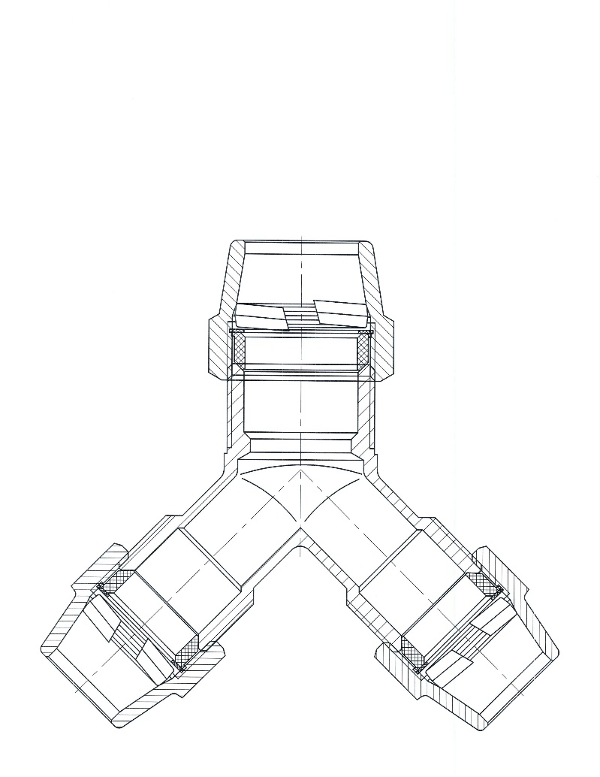

|  |  |  |  |
| --- | --- | --- | --- |
| Single Branch End | Multi-Branch Ends | Weight Lbs. | Part Number |
| 1” | ¾” | 1.98 | SY43GG-NL |
|  |  |  |  |

* Pack Joint Nuts are available upon request

**Features**

* All brass parts that come into contact with potable water conforms to AWWA Standard C800 (UNS C89833)
* Components that do not contact potable water conforms to AWWA Standard C800 ( ASTM B-62 and ASTM B-584, UNS NO C83600 – 85-5-5-5 )
* Classified to ANSI/NSF 61 and Annex G
* The product has “NL” letters cast into body of fitting for proper identification
* Valve is non-directional and is watertight with flow in either direction
* Ends are integral or secured with adhesive to prevent unintentional disassembly

**Utilities Supply, Inc. 575 Loganville Hwy Winder, GA 30680**

**Website: utilitiessupply.com**

**Email:** [**sales@utilitiessupply.com**](mailto:sales@utilitiessupply.com)